Appendix D
An example of a user specifying how the machine ought to re-present raw data.

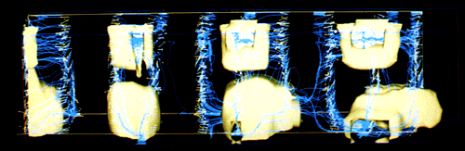
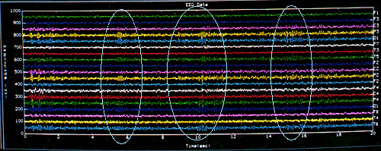

An example of a user specifying how the machine ought to present him with raw data.

In the images above, the squiggly lines represent specific physiological data and the shapes above are a different way of representing that same data, a much superior way. Let’s say we want to substitute all those squiggly lines from the EEG (brain wave machine) with 100 pages of English prose from a medical textbook on diseases. We aim to develop a program that can go through the electronic version of a medical textbook and turn particular elements of all that raw text into dynamical geometries of the kind you see above the lines (see also). For example, lets say we tell the program to query the medical textbook for two word roots: cardio(heart) and arterio(artery). Then we tell it to generate some primitive 3D shape for every 100 occurrences of the roots. The next step will be to then have this program begin to alter and complexify these shapes in accord with that part of all those words in the text which represent additions to these two roots (eg., cardiopulmonary, cardiotoxic, cardiothoracic, or arteriosclerosis, etc.). In this way we are attempting to get beyond text/words to represent data and into a new alphabet, a new literacy of multidimensional dynamical objects to take the place of all that text. Once the basic tools is developed, we can take a data base full of any content from medical textbooks, to the works of Shakespeare, or the works of Aristotle, or the Greek new testament, or the phone book, or the video catalog of the local Blockbuster and transform the significations of the text/words therein into the signifcations of dynamical shapes, etc. Intelligence analysis will be advanced by a quantum leap.

