Demonstration of TNG3 (TNG3_demo.ntl)
Purpose:

This program is designed to demonstrate how to develop a network using the TNG-3B serial interface. This program demonstrates the use of a calibrator and displays different outputs, depending on what type of sensor is being used.

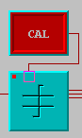
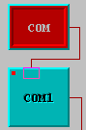
By turning on the “COM” and “CAL” Switch module, the LED in the top corner of the COM and Calibrate module is illuminated.

Both the COM and Calibrate modules are enabled at the top left port.

A separate Switch module is connected to the Calibrate module. This allows the user to only temporarily calibrate the sensor.



Note: The COM port number of this module and the COM port number that TNG-3B Interface is plugged into should match. In case the COM port does not work, check whether the port is being used by another device, such as a modem, or another program.
☑

TNG3 has many different output ports. Channels 1-8 correspond to the eight Analog inputs on the TNG-3B Interface. Channel 9 corresponds to all of the Digital inputs.

When an analog sensor is used, depending on what channel the sensor is plugged into on the TNG-3B Interface, the output is linked from that channel to the top input on the right side of the Calibration module, i.e. If the sensor is in Analog channel 1, the output from channel 1 on TNG3 module is linked to the input of the Calibration module.





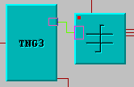

Note: TNG3 module only has 8 bits, as does the Decoder, Calibrate, and GreaterThan module. The default for all of these modules is 16 bits. These properties can be changed by right clicking on the module. The eight digital inputs are transmitted together as one byte (as are each of the analog channels) from the TNG3 module. The Decoder module extracts the individual bits, informing of the current state of the eight digital inputs.

☑
When Digital sensors are plugged into Digital Inputs 1 and 2 on TNG-3B Interface, the Decoder module is linked from channel 0 to the input of an LED module and from channel 1 to the input of another LED module. The LED modules become illuminated when the sensor is activated in the TNG-3B Interface.
Note: Channel numbers on the Decoder module begin at zero and count up to seven, instead of going from one through eight as they are numbered (1-8) on the right side of the TNG3 module.
☑


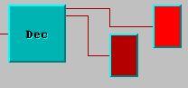

The output from the Calibration module links into three other modules. The ID Meter and 1D Viewer modules record the signals from the sensor.

When the sensor’s signal shown on the 1D Meter exceeds the limit set on the 1D Slider, the green LED light is illuminated showing that the signal is greater than the set limit.




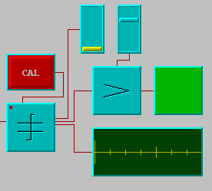
The 1D Viewer module displays signals from the sensor with respect to time.

The level of the 1D Slider can be changed.



