Lesson X - One-Dimensional Mouse Control Program
(TNG not required)

Purpose

- This program allows keyboard control of cursor position, a useful feature in some more advanced NeatTools programs. Open the file <mouse_drive1.ntl> so that the NeatTools window displays the program below.
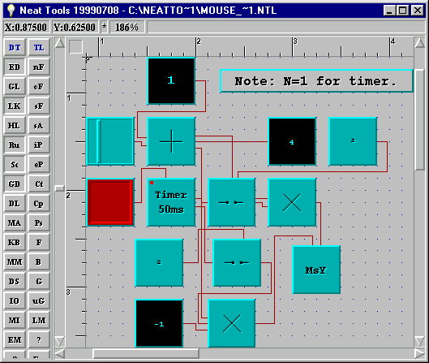

- Turn off the Edit Mode (ED) to avoid inadvertent alterations of the program. Then, place the mouse cursor on each module (without clicking) and read its name from the Status Bar.

How the Program Works

- Examine the overall flow of information (connections of modules) to understand in general how this program works. First, press the Link button (LK) on the Desktop Toolbar (DT) so that the links disappear. Now move the cursor over each icon to see where it is connected.

- This program allows control of cursor motion by the F11 and F12 keys. However, in order for this to work, <mouse_drive1.ntl> cannot be the active window. Moreover, any other program that uses the F11 and F12 keys (such as Microsoft Word) should not be active. To deactivate NeatTools, click on the Windows desktop so that <mouse_drive1.ntl> is still visible, but the Title Bar changes color. It may be necessary to resize the NeatTools window to do this.

- Press the F12 key to move the cursor right and F11 to move it left. Note that pressing the F11 alters the symbol on the bottom Control module and pressing F12 alters the symbol on the top Control module. Verify that when the red switch connected to the Timer is turned off, the cursor will not respond to F11 or F12.

- Regulate cursor speed by adjusting the 1DSlider. Moving it right increases the speed and moving it left decreases the speed. Note that adjusting the 1DSlider also alters the value of the Integer connected to it via the Add module.

- Note that the inputs to MsY are on the top (for incremental values) rather than the left (for absolute values). If you specify the absolute cursor position (X and Y coordinates) for the cursor, you can use the left inputs for an analogous program.

Exercises

1. Modify this program so that the F11 and F12 keys move the cursor vertically instead of horizontally. (Hint: you will need to open the I/O Toolbox on the DT toolbar.)

2. Right click on the Timer to change the setting to "N bit(s)[1-32]=16 bits", its default setting, and observe the change in behavior. Explain why a setting of "1 bit" is used for this program.

3. Make a new program that has a 2D mouse driver with a vector pad consisting of “i” for up, “k” for right, “m” for down, and “j” for left. In addition, allow the use of “u” for up, “r” for right, “d” for down, and “l” for left. Include a slider for varying mouse speed as in mouse_drive1.ntl. Verify that the mouse moves diagonally when two keys for neighboring directions (e.g. “r” and “d”) are pressed simultaneously. (A sample solution, <mouse_drive2.ntl> is provided).

