Biometric Security Technology

Biometrics use measurable unique human physiological or behavioral characteristics to verify or determine one’s identity. Various human traits are used for biometric recognition with varying degree of acceptance as well as accuracy. They are fingerprints, retinal and iris scanning, speech, facial recognition, hand geometry, voice pattern, handwritten signature, and other techniques such as thermal signature of the blood vessels in the head.

Recent advances in biometric technology allows a way to achieve faster and user-friendly authentication of one’s identity with a high level accuracy that is of great interest and importance to national security in protecting and controlling access to its worldwide facilities (rooms, buildings, perimeter, internet sites, etc.). In addition, a smart card-based biometric authentication allows rapid deployment to setup secure sites in the event of terrorist or other threats without having to build or access databases. A wireless technology can be incorporated with a biometric smart card to provide remote access to biometric information. For example, verification of a person wearing chemical and biological (CB) protective gear can be achieved with a wireless biometric smart card in one’s possession without the need to remove protective gear. In addition, combining several types of biometric technologies in a wireless smart card could form a network that is more capable and robust than a single biometric identifier.

In light of the recent terrorist attacks on the United States, especially on the State of New York, restricting physical access to potential vulnerable targets (i.e., public transportation facilities and vehicles; public buildings; critical infrastructures such as bridges, roads, tunnels, water supplies, electrical power grids, and communication systems) is a high priority. However, current forms of identification screening are vulnerable to human error and unable to discriminate amongst potential threat groups which include known high risk individuals such as terrorists, whereas, biometrics permit verification of a variety of unique individual characteristics.

Within New York State, there is substantial expertise in this very important area of biometrics from academe, government labs, and industry. Biometric methodologies and the NYS expertise within respective areas are listed below:

Syracuse University (Professors Lipson, Warner, Sarkar, Varshney, Chapin, Chin, Older, Du, Mansouri, Royer, Jabbour), MindTel LLC (SU incubator company, Edward Lipson, Ph.D. and David Warner, M.D., Ph.D.), and WetStone Technologies Inc. (Chester Husmeiz)
Applications of multisensory perceptualizations of information. All around the globe there are situations of human suffering due to natural disasters or military/terrorist activities. In such situations there is great need for water, food, shelter, and medical treatment, to name a few. In all of these there is an underlying requirement for information that tells the location and availability of all of these things. As an example, in the summer of 2000, there was an international mock humanitarian-assistance mission, called Operation Strong Angel, in a desolate lava field on the island of Hawaii. The World Health Organization, the International Red Cross, the United Nations (UNHCR, UNICEF, World Food Program), and other international organizations participated in Strong Angel, along with the militaries of seven nations. The exercise sought to encourage collaborative efforts between military forces and private-sector entities, with a goal of improving methods and matrices during disaster relief efforts. They propose to use the distributed medical intelligence and human-computer-interface technologies tested at Strong Angel to implement the wireless applications discussed above. MindTel can provide its modular core technologies for human-computer interfacing (NeatTools visual-programming software, and TNG serial-interface boxes that accommodate sensors and transducers, used in conjunction with PCs, handhelds (Palm and Pocket PC), micro web servers, and wireless technologies) that can be integrated into a customized distributed-intelligence matrix.
RF BioID for Humans. A RF BioID tag will be developed with various unique biometrics for an individual as shown in Figure 1. The fixed information, stored in the fixed memory, can be accessed by activating the card. This card is activated by sending a continuous wave (CW) signal at a fixed frequency. This will minimize stray excitations of the circuit. Also, the RF signal can be coded to excite a specific card only. Once the RF signal is received it will be rectified and will generate a DC signal for activating the remainder of the circuit. The objective of the rest of the circuit will be to update the information as to when the user checked in, for example, and the details of the past accesses and transmit that information to the base station. Of course, just having a device that stores and transmits biometric information in and of itself has no security value unless the information is digitally signed and certified by recognized and trusted authorities. Establishing and maintaining trust in distributed information systems is one of the main research interests of the Center for Systems Assurance (CSA). As it is likely biometric smart cards of this type will be also used over the Internet where having secure and correct time is essential to prevent fraud and misuse. SU’s CASE Center and CSA are working with WetStone Technologies Inc. in Cortland, NY to field a secure time service. SU proposes to devise a smart card that uses secure time to prevent vulnerabilities and fraud.
Fixed Memory
Transit Info
Time Out
GPS Data
Activated by outside RF Signal
Time In
Multi-Biometric Info
Fingerprint
retinal
iris
speech
facial
other
Biometric Smart card
Processor
Figure 1: Schematic diagram of RF BioID.

Polytechnic University (Professors Nasir Memon, Ed Wong, and Yao Wang)
Steganography. This term defines techniques that can distinguish between stego-objects (objects with hidden messages) and cover-objects. The Polytechnic group has developed techniques based on the observation that marking a cover-object like image, audio or video, leaves certain clearly distinguishable artifacts in the content that can be measured with the aid of appropriate quality metrics.
Image Watermarking and Authentication. Given an image, in digital or analog form, one can no longer be assured of its authenticity. Poly has developed a secure and powerful image authentication technique that provides significant advantages over conventional techniques.
Novel Fingerprint Verification Algorithm. Poly uses the computed “direction center” of a fingerprint image for matching key fingerprint features to provide a compact and unique representation of an individual's fingerprint. They propose to improve the algorithm performance in terms of accuracy and matching speed. They propose to extend the algorithm for “fingerprint search” or “fingerprint recognition” applications. Here the goal is to search or recognize an input fingerprint image among a large database of fingerprint images from many different individuals. An example application is to check whether a person is a known terrorist or criminal with a fingerprint record.
Face Detection and Tracking. Poly has developed rapid face detection and tracking techniques that can automatically locate face regions of various sizes, track the same face in successive frames, and identify similar faces that appear in different segments of a video. They propose to further extend this technique to improve its performance, and possibly to explore other more powerful techniques.

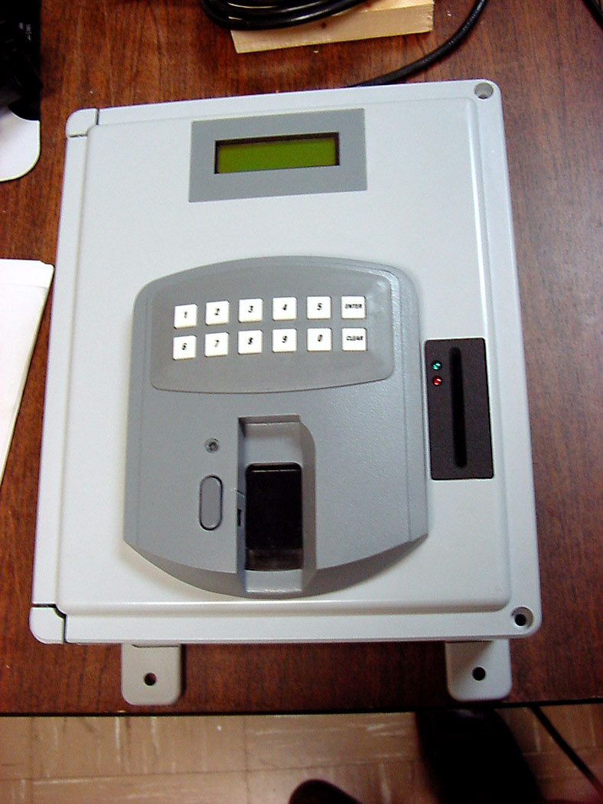
Ultra-Scan Corporation (Dr. John K. Schneider)
Ultra-Scan Corporation in Buffalo, New York, pioneered the use of ultrasound for live-scan fingerprint identification with accuracies greater than ten times those of competing technologies. They have deployed a number of large-scale ID systems worldwide. Ultra-Scan advantages are: superior accuracy (single finger accuracy of 0.01% false acceptance rate and 0.6% false rejection rate); real-world performance (accuracy unaffected by contamination on finger or fingerprint platen including moisture, through a protective gear such as latex gloves, glare, noise, electro-static discharge); integrated smart card (fingerprint scanner integrated with a smart card reader to eliminate the need for a biometric database anywhere in the system); and privacy protection (the only scanner to encrypt the ultrasonic fingerprint image internal to the scanner, preventing any unauthorized access to the fingerprint imagery). They propose to focus on the development, deployment and performance analysis of cutting edge biometric technology that can rapidly provide a scalable, cost-effective solution for a variety of security applications such as: perimeter security control; information access control; portable ID systems for police and border control; and multipoint biometric control of airports.
Figure 2: A Ultra-Scan smart card reader.

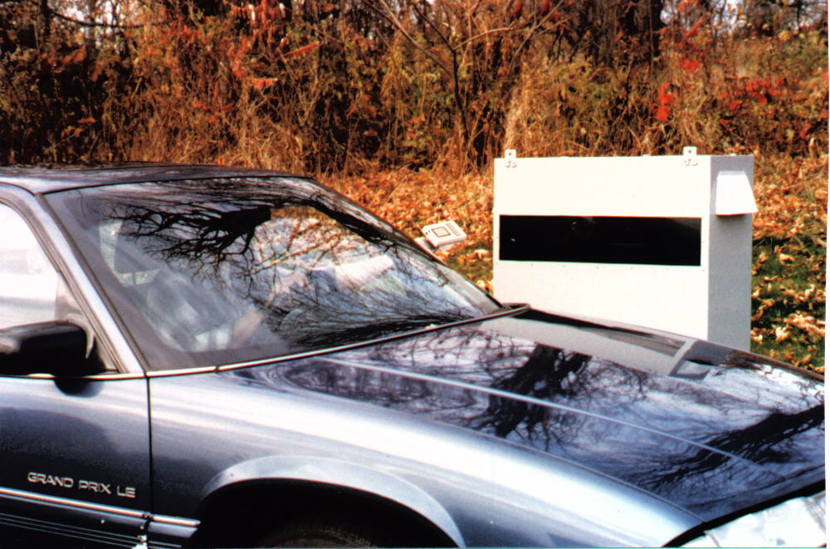
Syracuse Research Corporation (Stephen Abbe, MSEE)
Syracuse Research Corporation (SRC) completed an In Vehicle Voice Verification System (IVVVS) for border crossing application (i.e., access control). SRC has extensive knowledge and contacts in the areas of voice biometrics, fingerprint technology, facial recognition, and Iris scan. They have also worked with smart card technology and developed a prototype system that puts a person’s voiceprint on the card. SRC proposes to focus on a systems integration, signal processing, and rapid prototyping that will be valuable to the overall NYS efforts in this area.
Figure 3: The IVVVS system.

Air Force Research Labs –Rome Lab/Syracuse University/Rochester Institute of Technology/ITT Corp. (Drs. David Ferris, M.A. Slamani and Stanley Wenndt, and Professors Pramod Varshney and R. Rao)

Handheld Acoustic System for Concealed Weapons Detection. Developing handheld device to alert officers to the potential presence of a weapon at a greater distance than the handheld metal detectors in use today using acoustic technology. This device will be able to detect both metallic and non-metallic weapons, intended for criminal acts, concealed under an individual’s clothing.
Speaker Identification. With voice verification, a person’s speech sample is broken into smaller segments of about 20 millisecond. For each segment, a feature, such as the cepstrum, is computed. The goal is to captures information that is unique to each person’s vocal tract system. Being that the length of the vocal tract, the coupling in the vocal cavities, and the speaking styles vary greatly between people, most people have a “voice print” unique to them. The advantage of voice verification systems is that the equipment to collect and verify users is already in place – the telephone. Thus, voice verification can be used remotely.
AFRL has been involved in speaker verification for many years and has implemented numerous techniques to enhance the overall performance. AFRL was recently involved with a demonstration for telephone monitoring at correctional facilities. AFRL already has proven techniques in place for rapid prototyping and transitioning of technology. Thus, they propose to further extend voice verification by incorporating temporal information for text dependent verification through the use of autoregressive vector modeling.

Collaborative Project Deliverables
Within the first six months, it is anticipated that the Ultra-Scan fingerprint technology combined with smart cards will be available for implementation at various sites. A long-term project goal is to foster additional collaboration among the above experts to bring their collective knowledge and experience to bear on development of multi-modal biometric authenticity on a wireless smart card.

