OPERATION DESERT BLOOM

Medical Intelligence –initial status…

SAN BERNADINO

Loma Linda University Medical Center, 11234 Anderson Street, Loma Linda, CA 92354, 909.558.4000 tele

Medical: Linda has just been funded by TATRC to build situational awareness and emergency response tools for next generation disaster response centers. They are actively developing visualization tools to provide gps ambulance tracking, hospital resource inventory, in addition to a robust telemedicine network. Unfortunately none of the planned TM network is in place, and there are limited capabilities in house at the moment. ESRI is already working closely with Loma Linda to develop visualization tools which integrate REDDINET and vehicle GPS tracking. While they have just begun to develop most of these tools, they have identified specific software and vendors who already have products which will morph easily into this project. With regard to the Grand Challenge, Jeff Grange, who is PI on the TATRC Discovery Project, is also medical director for all SCORE races. He will be flying in the SCORE helicopter with the race bots and will support comms from the chopper to Mindtel ground stations. Loma Linda currently has in place a regional web portal called REDDINET, which provides the following data: ER diversion status, available services, incoming MCI (multi-casualty incident), ER capacity, staff availability, bed availability and trauma contact information for 40 trauma centers in southern California and east to the state line. We propose to integrate the REDDINET and Nevada’s version (EM systems) into three locations: COC, SAF, and BLM operations trailer.

51 ER Beds, 2 helipads, 18 pediatric beds, decon area, no burn, level I

Jeff T. Grange, MD, Director, Emergency Medical Services, 909.558.4344 tele, 909.558.1717x4859 (pager), 909.422.2680 (pager) jeffgrange@earthlink.net, jgrange@ahs.llumc.edu (ATA Member)
Jeff Bender, BSN, EMT-P, Manager, Discoveries Project, 909.558.7533, jbender@my2way.com, jbender@ahs.llumc.edu, 909.558.1717 x6411 (pager)
Davey Ellison, RN, MICN, Paramedic Liaison Nurse, Emergency Services, 909.558.8502, 909.558.1717x5009 (pager)
Jennifer Dearman, Charge Nurse, 909.558.4000 option 2, beeper 5734, extension 45717
Brett McPherson, 909.558.7592, brmcpherson@ahs.llumc.edu (backup for Jeff Bender)

Charge Nurses: 909.558.4000, select #2, then 51010, backup call – 909.558.4444, select #2, then ask to speak to the charge nurse.
March 12 – Teri Reynolds
March 13 – Jennifer Orr
March 14 – Tonya Herkes

Technical: Current technical abilities at Loma Linda for telemedicine connectivity at the moment are almost negligible, although they have identified a VTC unit which could be used as part of the readiness test during the Grand Challenge. They do have REDDINET operational from the standpoint of tracking hospital resources. They also have a teleradiology system in place that should allow us to do a connectivity test from the desert for a proof of concept demonstration for remote radiology reads from the race course route. Jeff Bender has been identified as the technical POC. Since Jeff Grange will also be flying the course during the race with Saul Fish, we have the opportunity to place technology aboard his helicopter for a number of different tests which we have not yet identified. One possibility is to simply do GPS tracking from the ground, much like we did at Burning Man, but there may be other opportunities that we have not yet considered. Since the Discoveries Project includes GPS tracking of ground and air vehicles, they will be interested in supporting communication link test with the SCORE helicopter and ground operations. Two action items which we are now pursing is to contact ESRI and REDDINET to integrate their capabilities into the SAF, COC, and operations trailer.

Other:

REDDINET, Healthcare Association of Southern California, 515 South Figueroa Street, Suite 1300
Los Angeles, CA 90071-3322

Linda Tripoli, Program Coordinator-Medical Communication Systems, 213.538.0709 tele, 213.203.4816 pager, ltripoli@hasc.org

ESRI, 380 New York Street, Redlands, CA 92373-8100

Ann Bossard, Hospitals & Health Systems, 909.793.2328, abossard@esri.com
Patty Helm (backup for Ann)

Major Tim Rapp, IPA/TATRC, 301.619.2413 or 301.619.7030
Jessica Kenyon, TATRC, 301.619.7036
Paul Fish, SCORE Racing
Lyn Behrens, President & CEO, 909.558.4308, rminor@ahs.llumc.edu (ATA Member)
Stephen Corbett, Department of Emergency Medicine, 919.824.0800x42848, scorbett@ahs.llumc.edu (ATA Member)

Images:

Arrowhead Regional Medical Center, 400 North Pepper Avenue, Colton, CA 92324-1819, 909.580.2601 tele

33 ER beds, burn trauma, 8 beds in trauma bay, no cardiac, level II,

Medical:

Mark Uffer, Chief Executive Officer, 909.580.6150 tele, ufferm@armc.sbcounty.gov
Khim Fugate, RN, Telemedicine Coordinator, 909.580.2619, fugatek@armc.sbcounty.gov
Rodney Borger, MD, Medical Director, 909.580.1410 tele, rodborger@aol.com, 909.580.1400 ED, borgerr@armc.sbcounty.gov (MaryAnn Russell, asst)
Joy Peters, RN, Paramedic Liaison Nurse, 909.580.1845, petersj@armc.sbcounty.gov
Jan Serrano, RN, Trauma Coordinator, 909.580.6116, 909.349.8769 (pager) serranoj@armc.sbcounty.gov

Technical:

Filmless radiology, videoconferencing equipment (ICON Networks System 3500)

Mark Taylor, Business Systems Analyst III, 909.580.2601 tele, taylorm@armc.sbcounty.gov
John Cairney, RT, Manager-Department of Medical Imaging, 909.580.1572 tele, cairneyj@armc.sbcounty.gov
Cindy Watkins, Information Systems Department, 909.580.2600, watkinsc@armc.sbcounty.gov

Desert Regional Medical Center (Palm Springs Medical Center), 1150 North Indian Canyon Drive
Palm Springs, CA 92262, 760.323.6511 tele, 760.323.6251 tele (Emergency Department)

Contact not yet established.

Mercy Air Services, 1670 Miro Way, Rialto, CA 92376, 888.499.9495

Wayne Richardson or Roy Cox

DESERT BLOOM BARSTOW

Barstow -
From Slash X we propose to integrate at least five switched video feeds to a single input VTC codec then IP connected at 786kbs to Barstow Community College. Five video sources will input to the switcher which feeds one ouput to either polycom, vbrick, or Tandberg flyaway codec kits. The link to BCC is about 6 miles as the crow flys, but terrain elevation changes will make total link about 9 miles. This may be doable with 2 hops of approximately 3 and 4 miles each. Target gps positions for hops have been identified and provided. Mindtel will supply 2 camera sources and it is requested that SRA provide video feeds through a Mindtel provided VDA of 2 video outputs from DARPA net sources. We request access to all video baseband video signals coming from INMARAT sources mounted on the cars. Two Mindtel cameras will be postioned on top of and around the BLM/Sheriff trailer. It is anticipated that DARPA camera feeds through the VBrick will include real-time video of both start and finish lines. The audio feed to codec to BCC will be 2 microphones—1 placed between the 3 radios in the sheriff’s trailer, the other a boom mike to Mindtel operations person in the trailer. Mindtel networks will not touch the IP side of ANY video signaling on DARPA course network. Internet data feeds to all Mindtel opps sites (BCC, Trailer at /x, COC) will include: REDDINET, EM Systems, and ESRI. Telemed and Telerad connectivity tests will originate primarily from MEDWEB sat truck and BCC. IP connectivity will be obtained from Barstow Community and at least one other source.

Slash X
The following frequencies and communication methodologies will be in place and are sensitive. Mindtel will not interfere with these modalities in any way: UHF radios – 450-470 mhz (used for comms with the bots on the race route); 900 mhz frequency (TDMA protocol) for emergency bot stop; 5.8 mhz microwave (startline to finish line with five injection points along the route); 2.4 ghz/802.11 wireless access points around start line; two vehicles with inmarsat onboard; 4 T1s along route traveling along 5.8 microwave network (2 of these are untouchable/2 of these are proposed for internet access).

Barstow College, 2700 Barstow Road, Barstow, CA 92311, 760.252.2411 tele

Issues
Room B-18 – Thursday, 7:30pm thru Sunday at midnight.
1 20amp circuit in the room, possible 2nd amp on light pole, third circuit on top of building
Lights – shut off at midnight ea night
Security – on campus most of the day; pull alarms and fire dept. comes, call Scott’s cell
Access/Keys – need at least one key for B-18
Trash can – need larger can to minimize cleanup

Parking available—it’s the weekend and no students on campus

Build AV list: Smart Board, Polycom FX 4000?, (2) lcd projectors, extension cords, CNN access/cable TV feed (RJ-59 cable from the library)

REDDINET, EMS Systems, ESRI,

Kurt Mitchell, Assistant Superintendent, kmitchell@barstow.edu
Scott Dewalt, Network Administrator, x7228, sdewald@barstow.edu, 760.252.6770 tele, 760.267.1153 cell
Ramona Boyton, Library/Instructional Media Tech, x7273, rboyton@barstow.edu, 760.617.4351 cell
Rex Vanderberg, Facilities Operations Director, rvanderberg@barstow.edu
Susan Jones, Public Relations, sjones@barstow.edu

Images
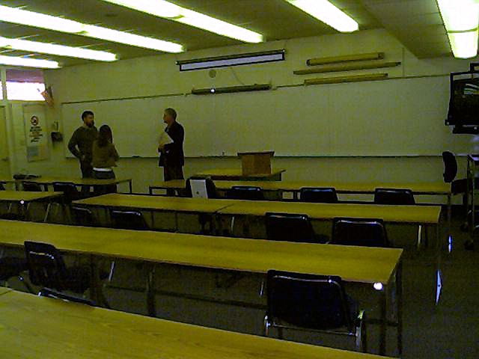
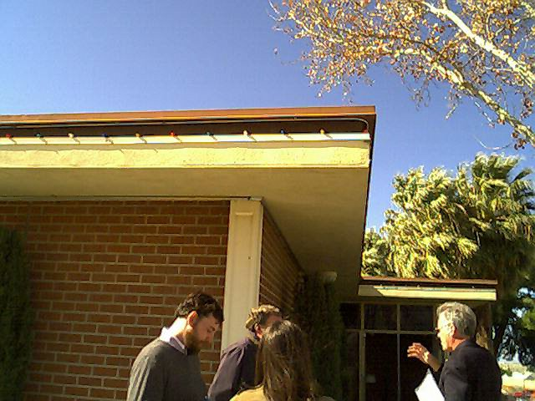
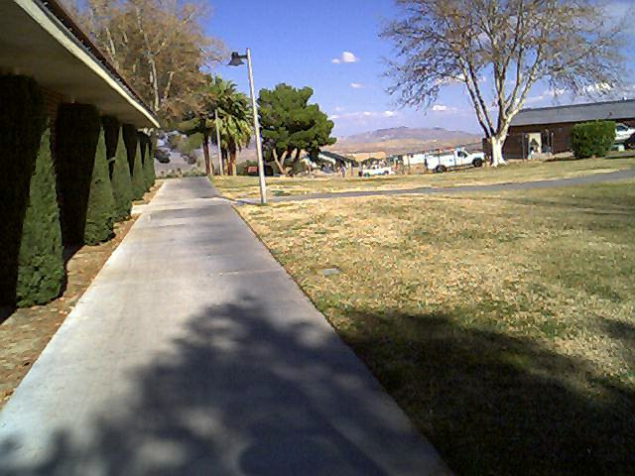

Bureau of Land Management, US Department of the Interior, 2601 Barstow Road, Barstow, CA 92311

No situation room in BLM building; however BLM building may have better line of sight to SlashX Ranch

Barry Nelson, Chief Ranger, 760.252.6070 tele, 760.255.6818 pager, barry_nelson@ca.blm.gov

San Bernardino County Sheriff’s Department, 225 E. Mountain View, Barstow, CA 92311

Sheriff’s Trailer

Run laser from top of comms boom on trailer; all data feeds go to trailer.
At the start line we would like at least two Mindtel RMO cameras on top of the trailer overlooking the the start line. We are contacting EM Systems and REDDINET to provide real time hospital status displays through a secure web portal to the trailer, BCC, and COC. ESRI will provide realtime graphic displays through same secure web portal. Mindtel proposes to do provide all non-DARPA bandwidth. Mindtel will install all baseband coax between SAF and Sheriff trailer. 2 cams from SAF to the trailer, and 2 video feeds from trailer cams.

Mike Cadwell, Reserve Deputy Sheriff, 760.256.4338 tele, 760.256.1796 or 911 (emergency)

Images:
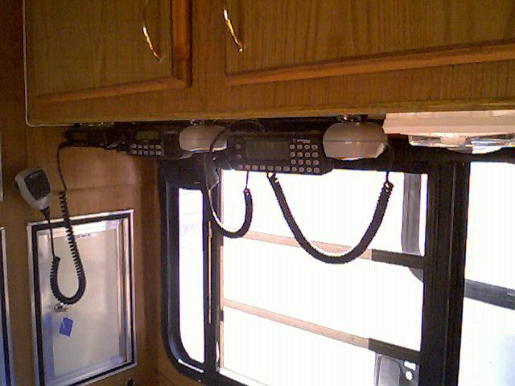
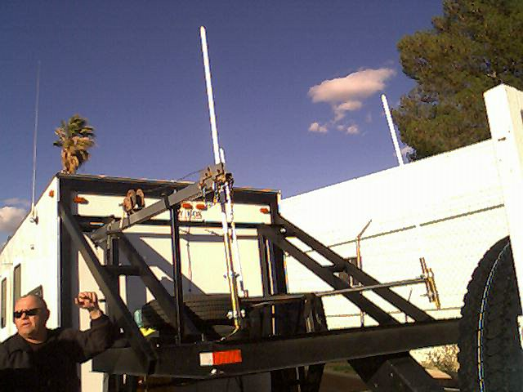
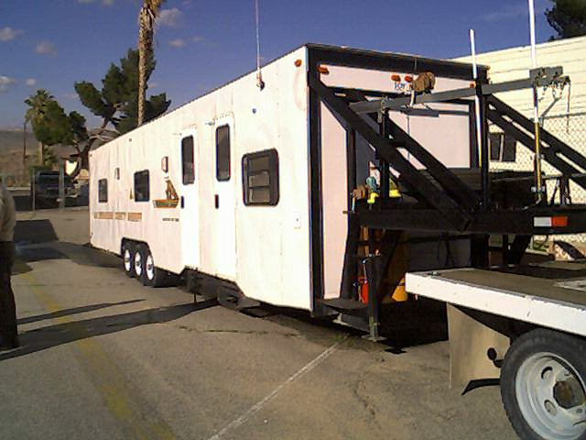

DESERT BLOOM LAS VEGAS

University Medical Center of Las Vegas, 1800 W. Charleston Boulevard, Las Vegas, NV 89102
702.383.2000 tele

ER – 36-09-35.893N Lat, 115-09-59.004W Long
Helipad will tolerate and is rated for 10,000 lb impact load
Radio comm.: Transmit Frequency 467.950, Receive Frequency 462.950
Landline # 702.383.3969

1 chopper in Henderson/1 chopper in boulder city, 11 resuscitation beds.
Monday is busiest day. Weekends should be fine to support this operation.

Medical:
Trauma Resuscitation Unit, 702.383.3969
Connie Brown, RN, Trauma Coordinator, 702.383.2092
John Filds, MD, Director of Trauma Services, 702.383.2092
Gregg Fusto, Clinical Manager-Trauma Resuscitation, 702.210.8395

Technical:
Ernie McKinley, Information Systems Director, 702.383.6567
Sarah Richardson, Information Systems Assistant Director, 702.383.1985, 702.808.9800 cell
Mac Mintz, Information Systems Security, x7397

University of Nevada School of Medicine, 2040 W. Charleston Boulevard, Suite 503, Las Vegas, NV 89135

Statewide backbone is scheduled by Dani Chandler, who is Reno. Getting into or out of this network with any video signaling requires going through one of their regional concentrators. They have dedicated 348K fixed circuits, which are switchable from the concentrator. They also have a 384kbs ISDN portal at one of the concentrator sites. There are no directly accessible IP video stations on this network.. Administration receptive to participating… but with their limited capabilities, it looks like working with AHEC on the connectivity tests would be prudent.

Dani Chandler, Telemedicine Scheduler, 775.784.6645 (Reno), 800.815.9462
Stephen McFarlane, PhD, Dean-School of Medicine, 775.784.6001, scm@med.unr.edu
Gerald Ackerman, MD, Dean-Rural Programs for SOM, 775.738.3828, Gerald@med.unr.edu
Rick Roehm, Medical Information Systems, 702.218.9620 cell,
June Boyko, Administrative Staff – SOM Dean’s office.

AHEC

Bob Boyko
John Yuhos, 702.318.8452 is the technical support guy for the AHEC network. He is very supportive and able to provide IP video connectivity with a Polycom 4000 for our tests from MEDWEB van and other sites. He seems quite will to work with us on connectivity tests on Friday March 12.

Medical

Technical

Images

